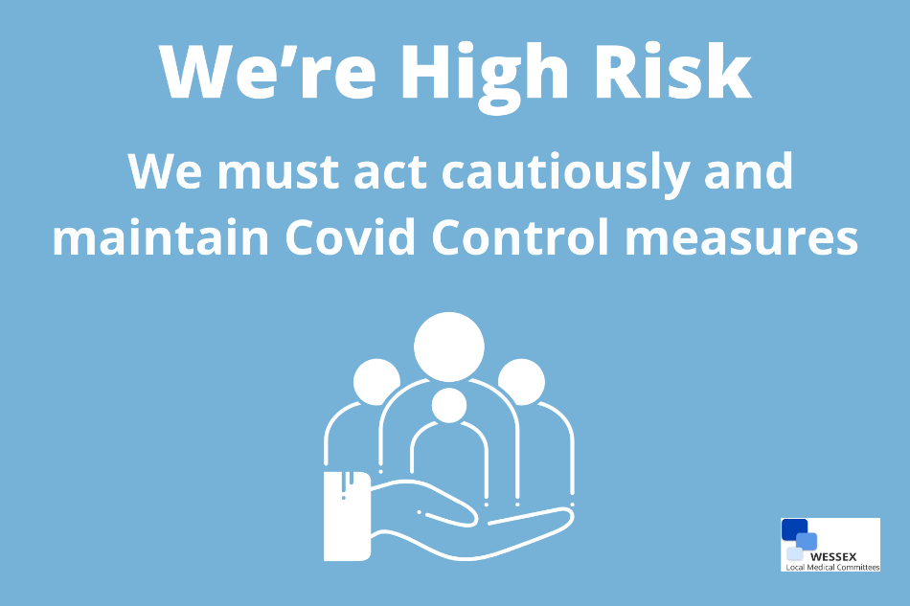

To all our Patients

We are aware of the planned move to lifting the remaining Covid restrictions in England from the 19th of July.

Medical settings are a higher risk environment and will need to be subject to more control measures than other public facilities.

We are acting very cautiously and are maintaining:
- Social distancing
- Face coverings
- PPE for healthcare staff

The delta variant is more transmissible and patients may come to the surgery when they are contagious.

It is our duty to do all we can to keep both our patients and our staff safe whilst we deliver our care.

Thank you
Victoria Cross & Eldene Surgeries

