SPRING COVID VACCINE BOOSTERS 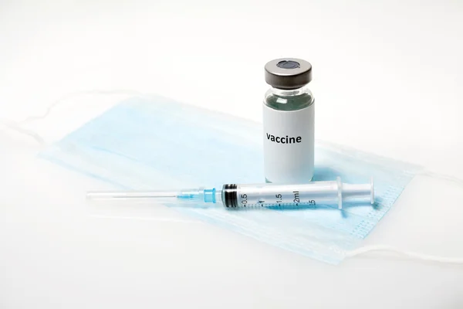

Eldene Surgery, Victoria Cross Surgery and Lakeside Practice will be calling all eligible patients to book your Spring Covid Booster Vaccine to be given at Eldene Surgery.
Eligible patients are:
- Patients who are 75 years or older
- Patients who are immunosuppressed

Unfortunately, this year we are unable to offer the vaccines to family members of the immunosuppressed or carers.
Vaccines will be given between April 2023 and June 2023 – all of our eligible patients have had a vaccine ordered for them already by their Surgery so please let us know if you are declining the vaccine this year.
Please do not contact the Surgery to check if you are eligible.
We will contact all those who are eligible for the Vaccine in the next few weeks.

